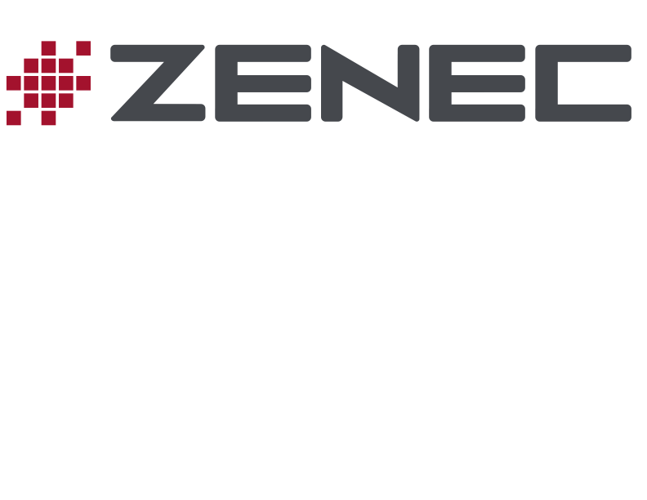

**PRESS REALEASE ZENEC Z-N326** APRIL 2017

**Optimum Smartphone Integration with the ZENEC Infotainer Z-N326**

**Flexible retrofit solution for any vehicle: the ZENEC 2-DIN system Z-N326 offers modern entertainment functions, allowing convenient mobile use of Android and iOS based smartphones.**

**SHORT**

With the Z-N326 the Swiss specialist ZENEC has launched a 2-DIN infotainer with important innovations on the market: connection of Android and iOS based smartphones via ZENEC's new SmartLink Direct function, two USB ports, FM tuner with Next Level tuner chip for best sound and reception stability, Bluetooth unit for hands-free calling and music streaming, 10-band equalizer, HDMI input, connections for rear-view camera and steering wheel remote control – you could hardly expect more from a modern entertainer. But also for those who want a versatile sat nav with all the comfort functions, the new ZENEC is an intelligent solution: with the microSDHC card Z-N326-SDFEU available separately the Z-N326 can be expanded into a navigation system with a full range of functions.

**LONG**

With the Z-N326 the Swiss specialist ZENEC has launched a 2-DIN infotainer with important innovations on the market: The Z-N326 offers modern entertainment functions, excellent sound quality and ease of use. But that is not all. Thanks to SmartLink Direct the Z-N326 enables easy integration of the latest Android and iOS based smartphones. Also for those who want a versatile sat nav, the XZENT is an intelligent solution: with the microSDHC card Z-N326-SDFEU available separately the Z-N326 can be expanded into a navigation system with a full range of features.

**Comfortable connectivity with smartphone**

Communicate on the move, enjoy music, navigate and much more – the Z-N326 makes it possible: Smartphone and multimedia system merge into a high performance infotainment unit. Android and iOS based smartphones can be directly docked with the Z-N326 via USB. Thanks to the new SmartLink Direct software, screen content, including Apps, is then mirrored on the large display of the ZENEC infotainer. With Android based smartphones SmartLink Direct also enables direct App control from the touchscreen of the Z-N326.

**Capacitive display – modern infotainment features**

The minimalist design of the Z-N326 offers a high quality capacitive 6.2"/15.7 cm touchscreen display that can be intuitively used while driving – a slight touch or tap is all it takes. The high brightness level, the clarity and brilliance of the screen, but also the large contrast range underscore the premium quality of the new ZENEC system.

The Z-N326 is a top modern entertainer that looks convincing with its wide range of functions. The FM tuner with Next Level tuner chip ensures optimal radio reception, as well as a clear sound when stations are weak, thanks to adaptive noise reduction. The Z-N326 has two USB ports for docking the smartphone and for A/V playback via USB. In addition, there is a HDMI input for connecting compatible multimedia devices, smartphones, or tablets with the Z-N326. For individual sound tuning there is a 10-band graphic equalizer and various predefined EQ profiles.

The comprehensive Bluetooth unit provides safe telephony while driving, and simple management of phonebook entries, as well as comfortable A2DP music streaming.

**First class sat nav – easy retrofits**

If using smartphone sat nav apps is not enough, for a reasonable price you can upgrade the Z-N326 to become a high end naviceiver. With the microSDHC card Z-N326-SDFEU available separately the infotainer can be expanded into a navigation system with a full range of features and the latest comfort functions. With detailed maps for 47 European countries, more than 6 million points of interest, 3D Auto-Zoom for junctions and roundabouts, and free map updates for one year, getting the latest navigation technology in your car is really very straightforward.